SOCIAL CUSTOMS – THE PHARAOH
The word “pharaoh” means “Great House” after the palace where the pharaohs lived. The pharaoh was not only king (or queen) but also a living god, directly related to Amun, later known as Re the Sun God. The pharaoh’s crown was two crowns in one. The tall, white head-dress was the crown of Upper Egypt; the short red head-dress was the crown of Lower Egypt. On the front of the double crown was a cobra. Pharaoh’s usually wore a false beard and carried a crook and a flail.
‘Every hour was definitely set aside for various duties….not for pleasure. On rising in the morning the first thing was to read the messages which had arrived, and this probably involved dictating the replies. Then came the ceremonial purification and putting on the robes and badges of office. Then came the sacrifice.
Before this the high priest with the King and the people standing around him prayed for the health of the King, recited the praises of the King and then put a curse on all mistakes that had been made, putting the blame on the ministers.
After the sacrifice, the King inspected the entrails….he then finished the sacrifice…..with offerings of wine and oil. Then came the sermon when the priests read the laws and historical passages suitable for the time.
The food of the King is said to have been plain and limited to preserve his health and through this the health of the country.’
QUEEN HATSHEPSUT (1503-1482BC)
She was the widow of Tuthmosis II. She ruled instead of her stepson Tuthmosis III. She refused to give up the throne even when he was 18.
She avoided wars and instead concentrated on building up trade. She sent a number of ships to seek out places that the Egyptians could trade with. The result was that important trade routes were opened up for Egypt.
She had some temples and monuments built but most were pulled down or defaced by Tuthmosis when he became pharaoh.
TUTANKHAMUN (1361-1352BC)
He was still a child when he came to the throne. He died when he was only 17 or 18. Very little is known about what he did. There’s no record of any wars but we do know that he had a number of temples rebuilt. His tomb was discovered in 1922. His possessions and many valuable treasures were found with his mummy. This is the only royal tomb which has been found intact.
RAMESES II (1292 – 1225BC)
He was a great soldier who made Egypt more powerful by war and conquest. He fought a long war against the Hittite Empire. In 1285BC he claimed he fought single-handed against the whole Hittite army and won. It is certainly true that he led and inspired the army.
He signed a peace treaty with the Hittites and married a Hittite princess. This made Egypt safe. Then he built the largest and most impressive monuments and temples in Egypt. He ruled for more than 60 years. He married many times and had more than 100 children.
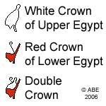 Crook and Flail 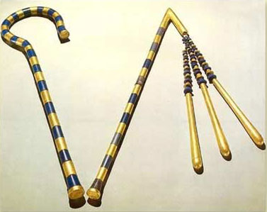
ACTIVITIES AND RESEARCH QUESTIONS:
- Why did the Pharaoh wear a double crown?
- What do you think the crook and flail represent/
- Colour the crowns of Egypt.
- Construct a timeline to show the periods which each of the three Pharaohs on the previous page ruled. Hint: The timeline should be 14cm long and each cm should represent 20 years.
- List at least five duties of the Pharaohs.
- Why was it necessary for the Pharaohs to enlist the services of others to help him with his duties?
- Draw a picture which represents the Pharaoh. Below this picture write the three types of deputies employed by the Pharaoh to help him govern the land. Below the three types of deputies, write down the specific tasks they had.
- Who could become a Pharaoh?
- Why was it useful for the Pharaoh to be thought of as a God?
- What might be some of the disadvantages of being the Pharaoh?

